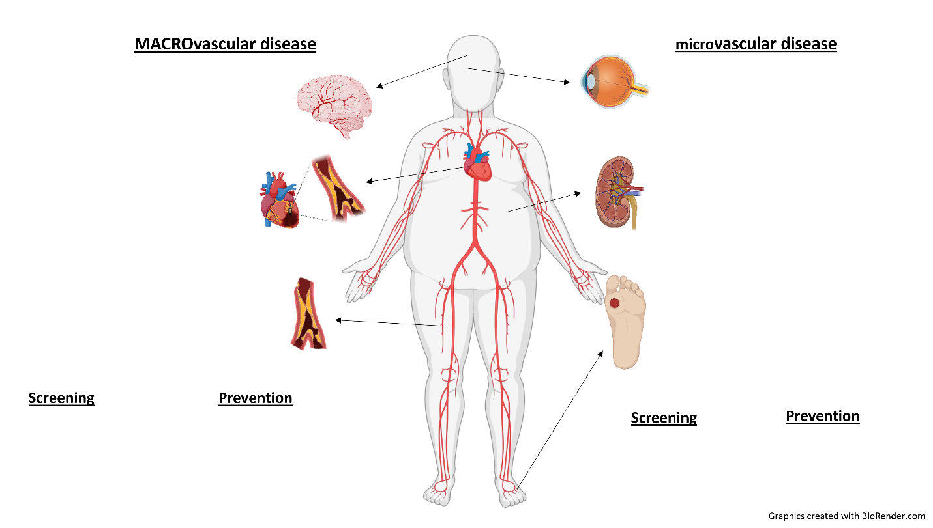

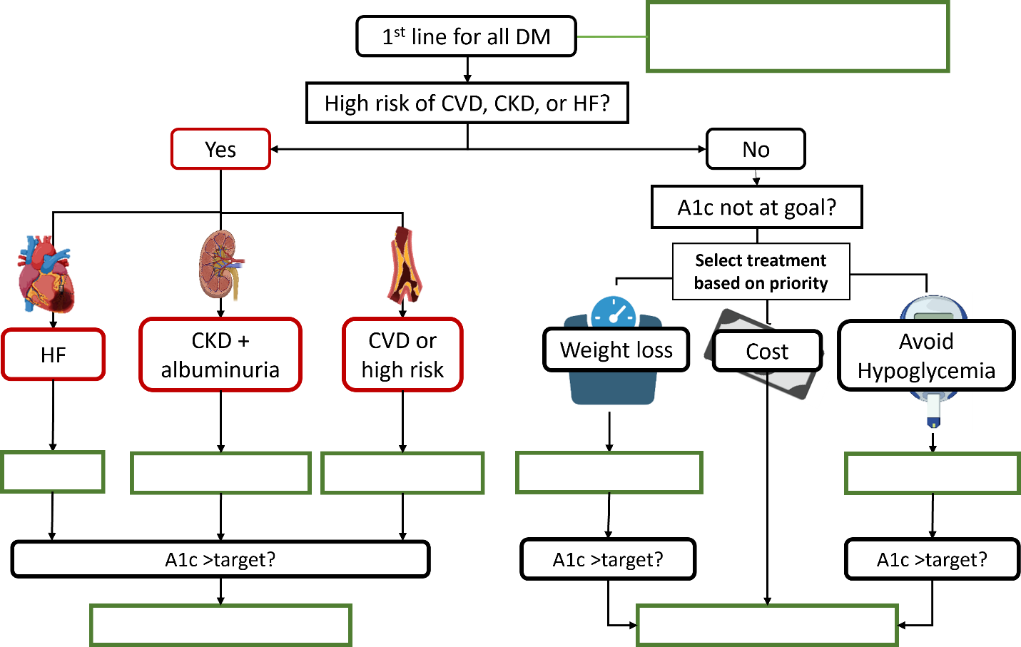
Class | Benefits | Side Effects/ Contraindications | A1c effect

(Answer Key)
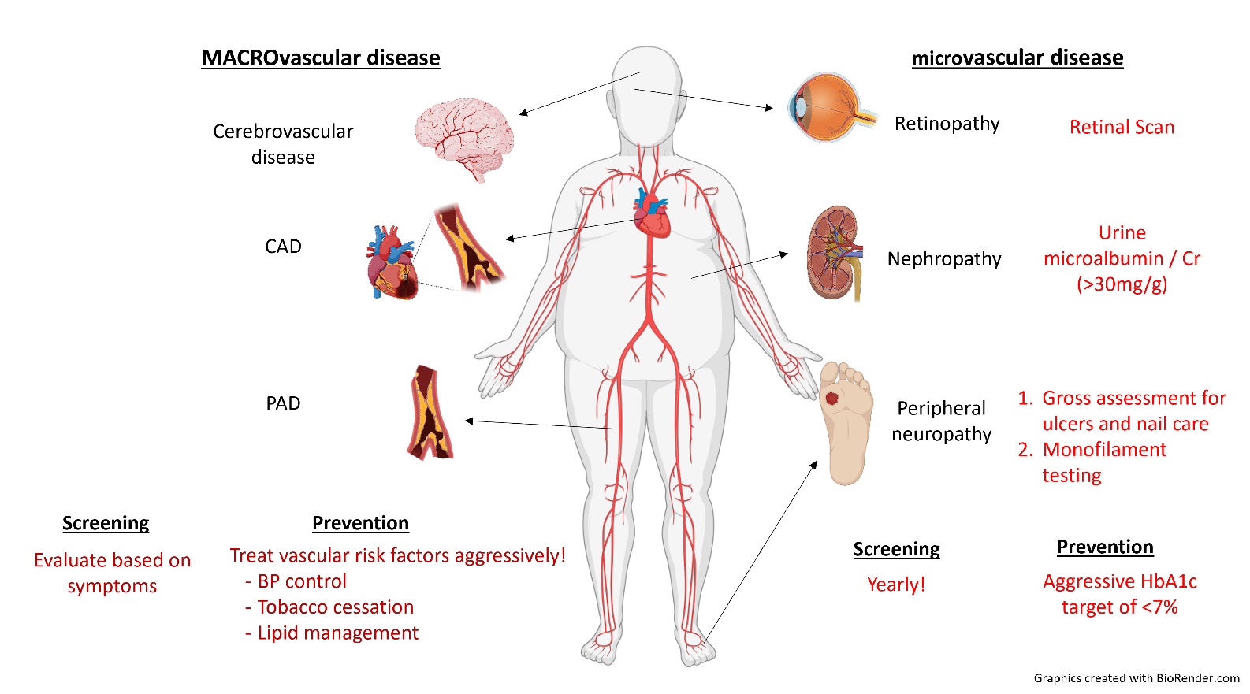

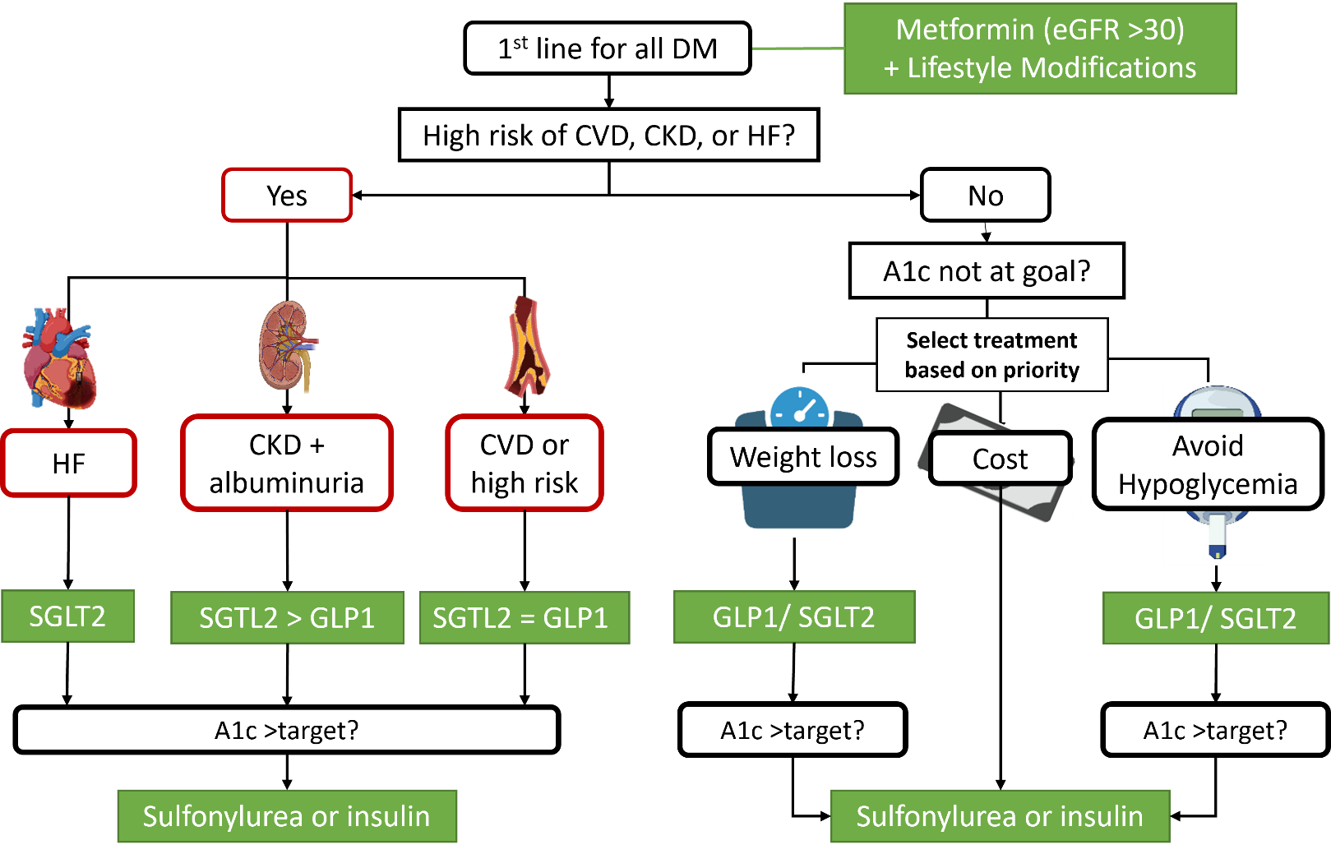
(Answer Key)
Class | Benefits | Side Effects/ Contraindications | A1c effect
Metformin  PO|$ | Weight neutral  Possible ↓ ASCVD risk | GI side effects (lower in ER formulation or when slowly uptitrated)  Avoid in GFR < 30 (risk of lactic acidosis)  Neuropathy, B12 deficiency | 1-2%
GLP1 agonists  SQ (*PO)|$$$  (liraglutide, duraglutide, exenatide, semaglutide*) | Weight loss  ↓ major CVD events  Improves renal outcomes | GI side effects  Potential risk of thyroid C-cell tumor  Pancreatitis | 0.5-1.5%
SGLT2 inhibitors  PO|$$$  (canagliflozin, empagliflozin, dapagliflozin) | Weight loss  ↓ BP  ↓ major CVD events  Improves renal outcomes | Candidiasis, UTIs, Fournier’s  Euglycemic DKA  Hypotension  Bone fractures (canagliflozin)  Possible risk of amputations | 0.5-0.7%
Sulfonylureas  PO|$  (glipizide, glimepiride, glyburide) | Rapid effect | Weight gain  Hypoglycemia  Avoid glyburide in CKD | 1-2%
Insulin  SQ|$  (Glargine, NPH, regular, lispro, aspart, U-500, U-300) | Rapid effect | Weight gain  Hypoglycemia | 1.5-3.5%
Diet modification  $-$$  (caloric restriction) | Weight loss  Potentially curative  May ↓ BP, ASCVD risk, NASH | High relapse rates | ~0.5%  (related to degree of caloric restriction and weight loss)
Bariatric surgery  $$$  (Roux-en-Y, gastric band/sleeve) | Weight loss  Potentially curative | High relapse rate of DM (30-50%)  Complications of surgery (malabsorption, anastomotic ulcers in Roux-en-Y) | 2%

